Day9Lab
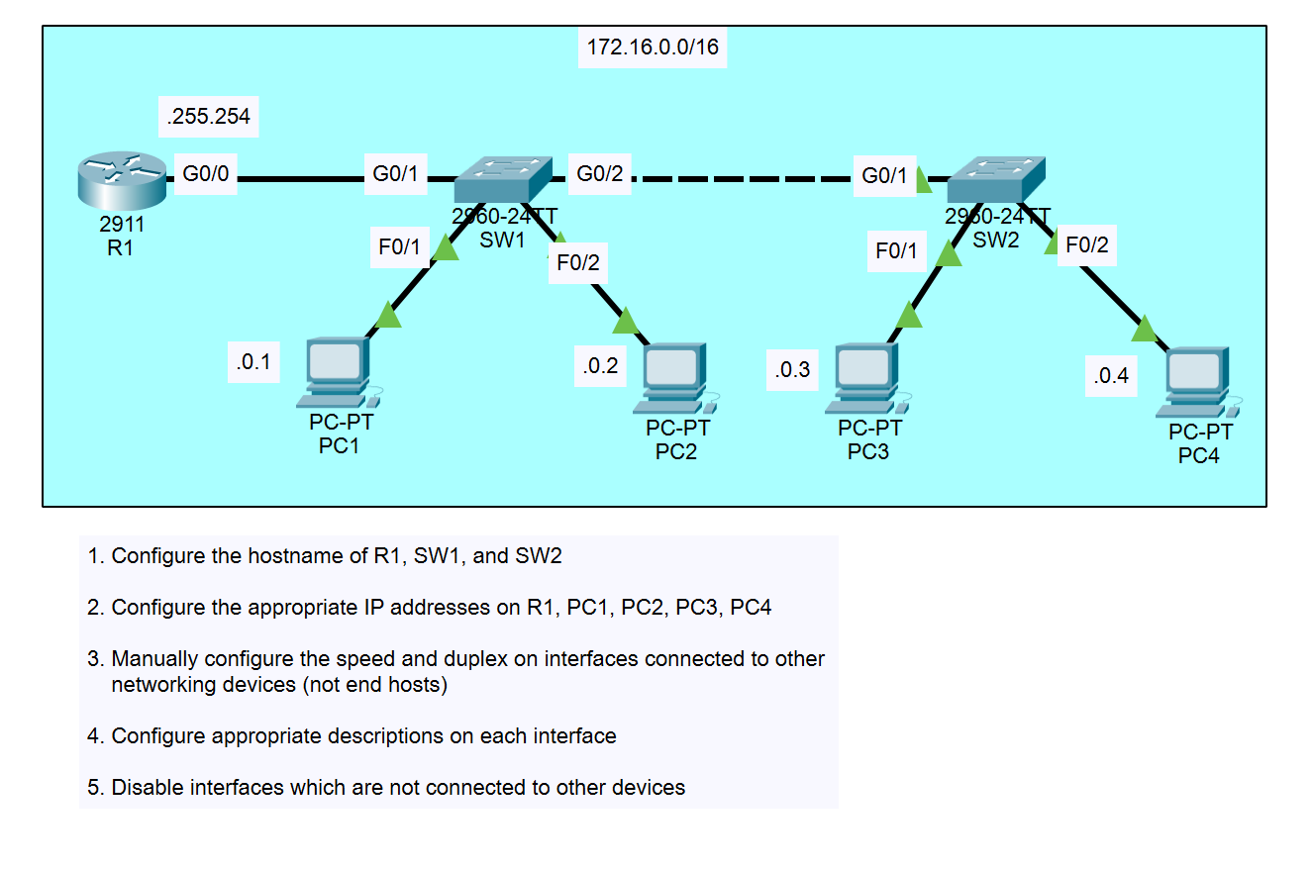
- Configure the hostname of R1, SW1, and SW2
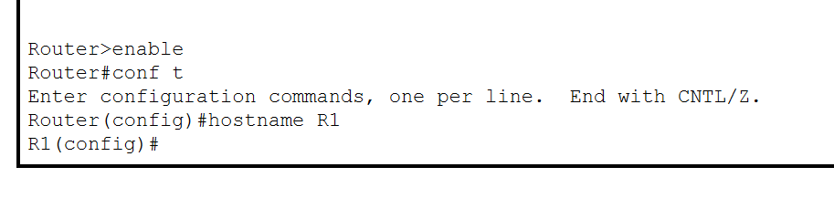
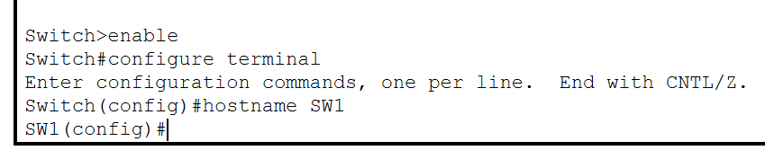
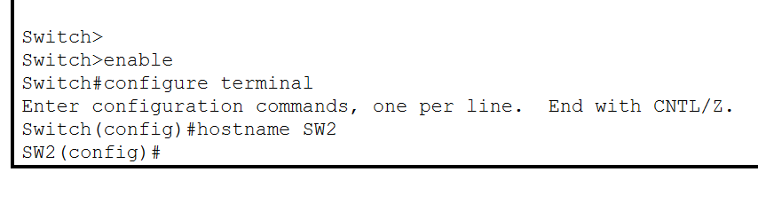
- Configure the appropriate IP addresses on R1, PC1, PC2, PC3, PC4
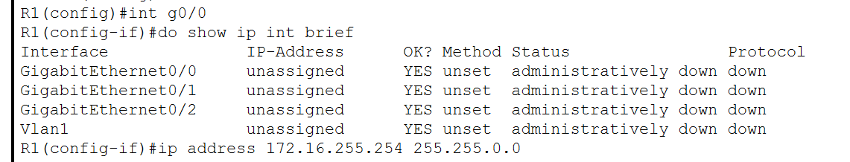
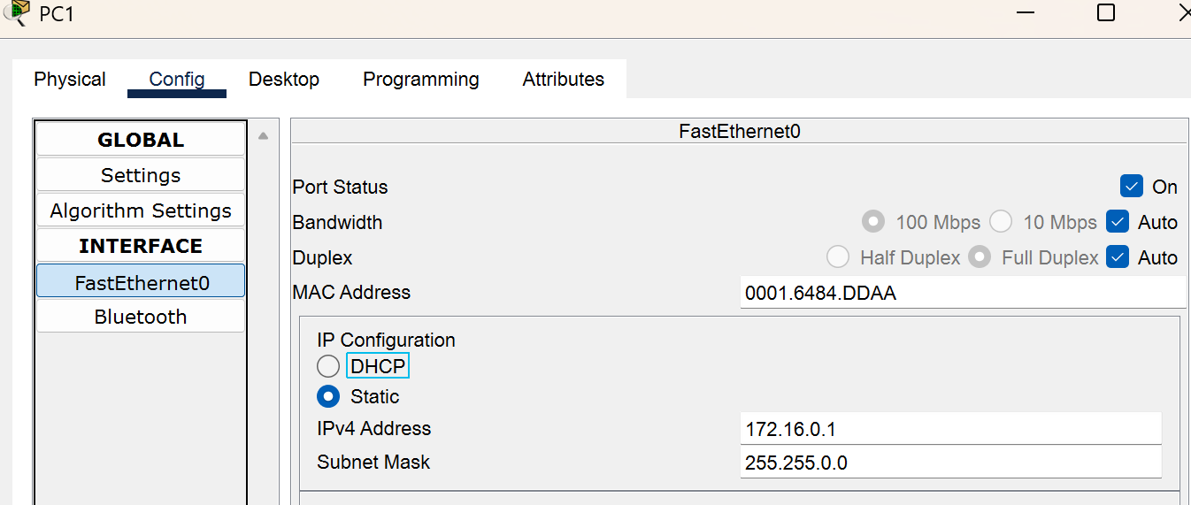
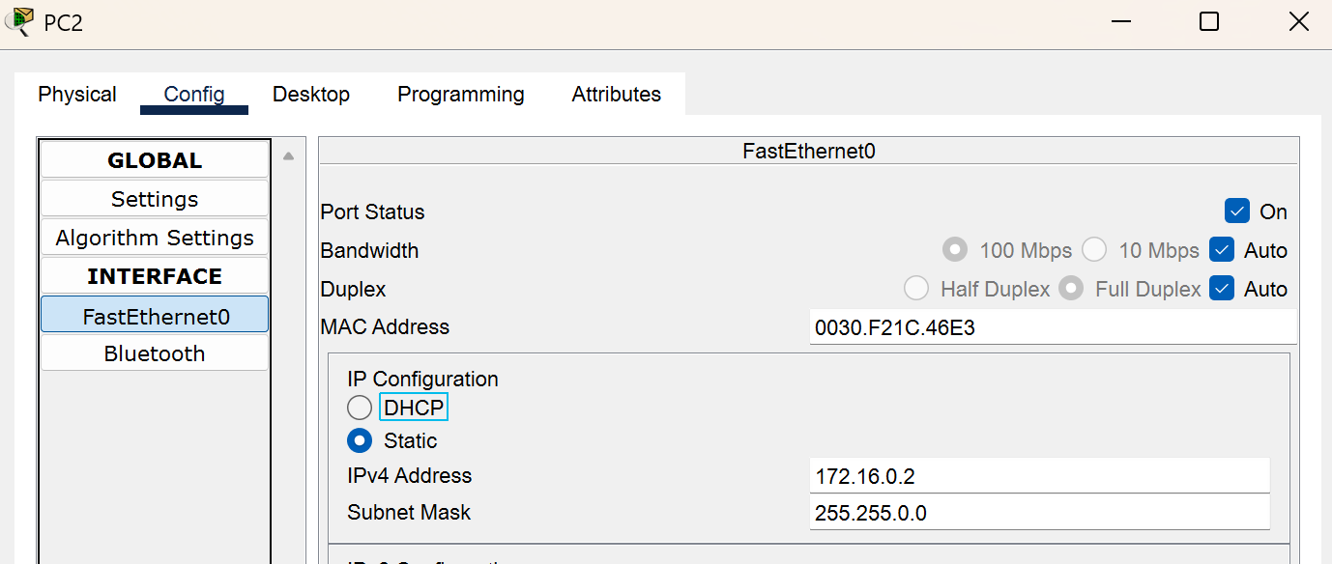
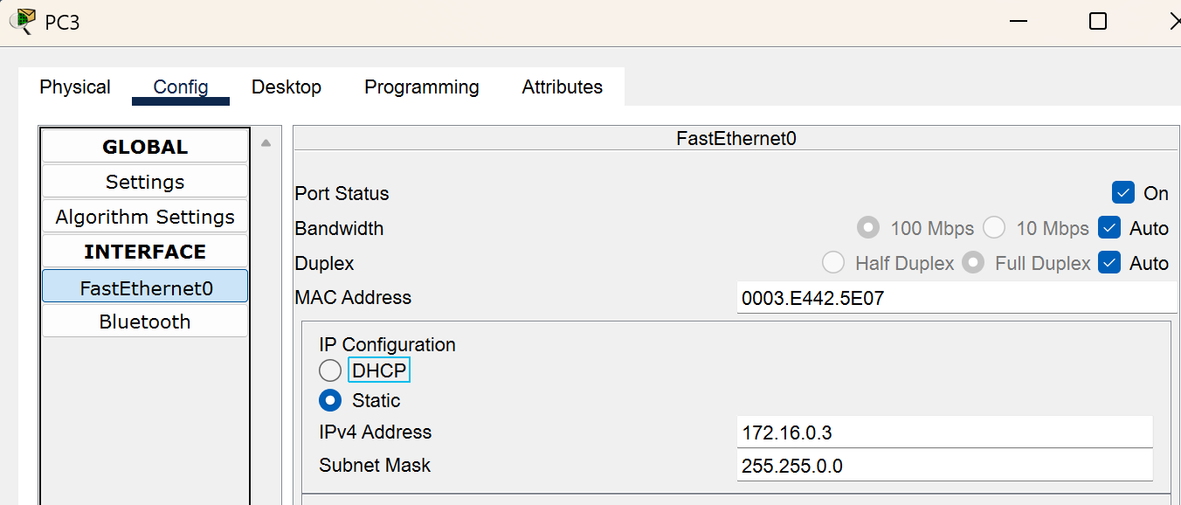
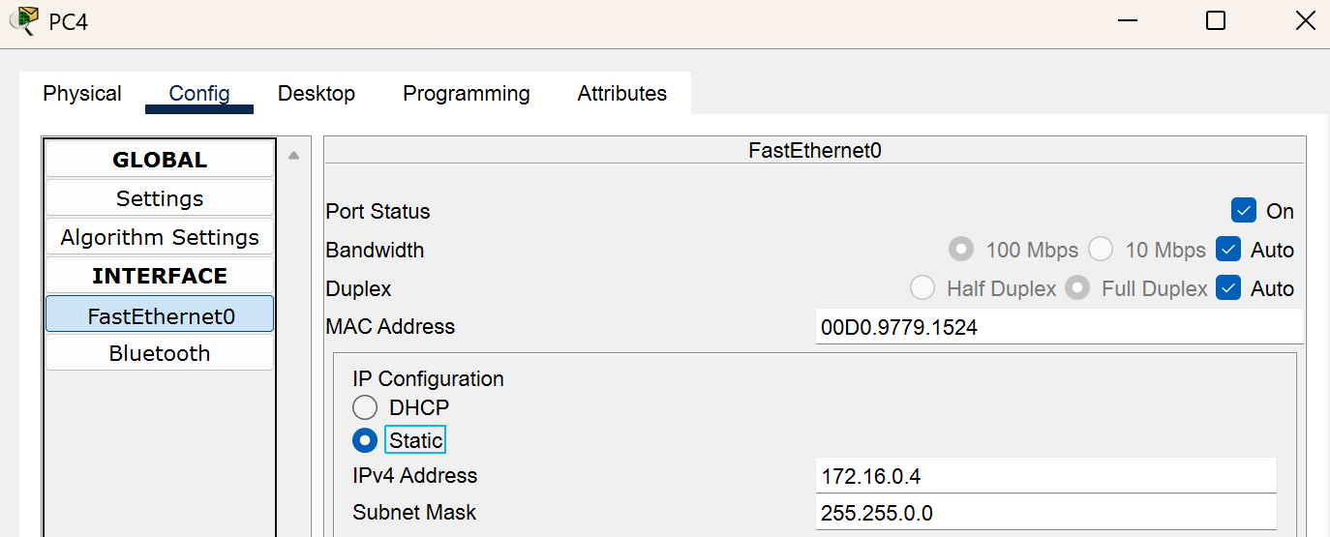
- Manually configure the speed and duplex on intefaces connected to other networking devices (not end hosts)

- Configure the appropriate descriptions on each interface
- Disable interfaces that are not connected to other devices
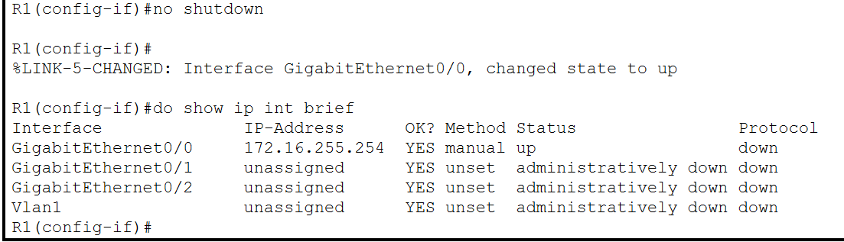
- Save the configurations
